The Use of Propaganda in Influencing Women’s Body Image
Taylor J. Stickles
University of Rhode Island

Abstract
Propaganda and advertising have worked hand in hand for more than a century to shape the attitudes of the public, influence their actions and persuade them to buy products. Every piece of propaganda is created with a specific purpose and a specific target audience in mind. One group that has been particularly targeted by marketers and propagandists for decades is women. Women make up roughly 50% of the American population and thus have major buying power. Women have been specifically targeted with propaganda designed to influence their attitudes and opinions of beauty and body image over the past few decades.
This paper will examine two examples of propaganda, each with the intention of shaping women’s view of their bodies. The examples highlight the differences between 1960s and 2000s propaganda. The 1960s propaganda is an advertisement created by an ironized yeast company attempting to sell more of its product with an image of a woman claiming “Men wouldn’t look at me when I was skinny.” This was a part of a cultural movement in which advertisers dispersed various propaganda urging women to use weight-gaining products once they deemed curvy figures as the new ideal. On the other hand, the 2000s propaganda is from Dove’s modern “Real Beauty” campaign and features a group of diverse women with the words “We see beauty all around us.” The purpose of this campaign is to convince its audience that Dove is a brand that empowers and celebrates all women’s bodies. While one piece of propaganda seeks to shame women’s bodies, the other’s goal is to empower them. However, while the examples may seem drastically different, they share the same goal of influencing the way women view their bodies in order to sell the brands’ products.

History of Propaganda: From origin, to 1960s, to today
There is no one definition for propaganda, as it is a medium that has been ever-evolving since its origin in the 1500s. Over time, it has become known as a means of disseminating information and influencing the public’s opinions and actions on a matter. Some view propaganda as a positive tool for helping inform audiences about a particular issue of importance, while others see it as a immoral weapon used to manipulate and mislead people. In reality, propaganda can have either of those effects, depending on how it is used. It is important to note both the “good and bad” and “right and wrong” uses of propaganda in order to fully understand its power to inform and persuade the masses.
No matter what the purpose, every piece of propaganda incorporates many techniques to strategically convey its message to its intended audience. What all propaganda has in common is that it is deliberate and created with a specific purpose in mind, usually to further the interests of the propagandist. “The ‘purpose’ of the propaganda is therefore the key. Without purpose, propaganda can have no aim and direction, and therefore no distinctive function differentiating it from other social and political activities” (Doob). The cause is then formulated into a strategically-crafted message, which is disseminated to its target audience with the intention of influencing action and opinion.
The kinds of propaganda most commonly recognized today became increasingly popular in America around the time of World War I. The early-mid 1900s saw not only war-related propaganda, but other kinds, as well. This time period also saw the beginning of print advertisements, a medium that has greatly evolved into the marketing conundrum that exists today. However, many advertisements during this time were not simply created to sell products, but to influence attitudes and lifestyles, as well. One way propaganda was defined in the 1960s was “the deliberate attempt by some individual or group to form, control, or alter the attitudes of other groups by the use of the instruments of communication, with the intention that in any given situation the reaction of those so influenced will be that desired by the propagandist” (Qualter, 1965). During this time, it was common to see propaganda posters with images that evoke strong emotions, usually along the lines of love, anger, fear or hate. No matter what the cause, propaganda was becoming more popular and effective during the time period, but has since advanced even further into the world of advertising and marketing.
Nowadays, propaganda can be defined as “a deliberate attempt to persuade people to think and then behave in a manner desired by the source; public relations, a branch of propaganda, is a related process intended to enhance the relationship between the organization and the public. Both in turn are related to advertising” (Backer, 1993). Much of modern advertising consists of propaganda-like marketing strategies and public relations campaigns. Every major company has at least one public relations, marketing and advertising firm working to spread its messages and guard its reputation. One might say that these agencies are disseminating propaganda for these companies based on the modern definition of it: “The usually organised spreading of ideas, information, or rumors designed to promote or damage an institution, movement, etc” (The New Penguin English Dictionary, 2000). In a society so cluttered with advertisements, companies have to find a strategic, creative way to break through the noise and reach their target audience, and that often must be done with propaganda. Propaganda and advertising now overlap because: “The basic definition of advertising is a message or group of messages designed with three intentions: to raise awareness in the population about brands, products and services; to encourage consumers to make purchases; and, ultimately, to inspire people to advocate for their favorite brands” (Poepsel). Marketers have taken advantage of propaganda techniques to enhance their campaigns, which often do more than just sell a product. Brands must now find ways to connect with their audiences and form relationships with consumers to keep them loyal and trusting of the company. Propaganda campaigns are a way to disseminate information and influence attitudes about a brand or product in a creative, attention-grabbing way.

The Effects of Propaganda and Advertising on Women’s Body Image
It is no secret that propaganda and advertising greatly influence and often negatively affect women’s body image. Much of women’s advertising is overly sexualized and exploitative, often portraying unattainable images of skinny, beautiful women. However, this was not always the case. At one point in time, propaganda was created to convince women to gain weight to become more desirable to men. Still, these pieces of propaganda were created with the intention of influencing the public’s opinion of what an “attractive” woman’s body should ideally look like. They convinced both men and women that “skinny” women were unattractive and undesirable, thus shaping the attitudes of the time period. As a result, women who did not have the “ideal” curvy body were taught to think poorly of themselves, and feel as though they were unworthy of love, affection and attention. In reality, this was a ploy used by the propagandists to sell weight-gaining products.
Today, most advertisements portray beautiful, skinny women as the “ideal.” Most models are extremely thin and attractive, presenting unrealistic standards for women to look up to. Marketers play on women’s insecurities and body image issues by selling and advertising products like makeup, anti-aging creams, diet pills, etc. However, in recent decades, some companies have decided to go in the opposite direction and create propaganda campaigns for their brand that empower women and teach them to love themselves. While this typically has more positive effects on women than traditional advertising, it is still a form of propaganda. The campaigns are created to promote positive attitudes towards the brand, which is a strategic form of marketing by using propaganda tactics. Marketers have found an effective way to sell their products to women, and it involves influencing the way they see their bodies.

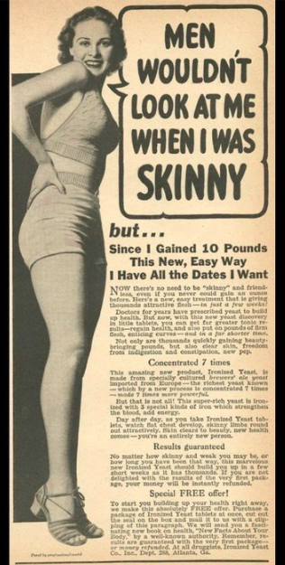
1960s: Ironized Yeast “Men Wouldn’t Look At Me When I Was Skinny” Ad

The 1930s - 1960s was a time period in which women’s beauty standards were seemingly opposite of what they are today. Skinny bodies were shamed in advertisements that promoted fat and curves to sell weight-gaining products like ironized yeast. During this time period: “The ads tout scientific ways to "add attractive pounds and inches" (a complete oxymoron in this day and age) and "add glamorous curves to your figure." And it wasn't about health: the ads make it clear that being skinny or slender is the least attractive look” (Krupnick, 2011). This is a form of propaganda because its purpose is to influence the public’s attitudes on the subject of beauty and body image, and persuades women to act upon their insecurities by buying a product. In particular, the “Men Wouldn’t Look At Me When I Was Skinny” advertisement evokes the strong emotion of fear, which according to Ryan Holiday is the number one motivator to make an action. This piece of propaganda plays on women’s fear of male rejection, as during this time period, finding a husband was considered the most important task for a young woman. The first line of the advertisement reads: “Since I have gained ten pounds this new, easy way I have all the dates I want. Now there’s no need to be “skinny” and friendless, even if you could never gain an ounce before.” By making women feel as though their bodies are unattractive if they are too skinny, the ironized yeast company sells more of its product to combat their fears. Women are known to have strong emotions, so evoking the fear of rejection and loneliness was an effective way to reach the target audience. With the rise of weight-gain propaganda, both men and women began to idealize thicker, curvier bodies. The propaganda was successful in changing society’s idea of “beauty” and therefore, more weight-gaining products were sold to women.

2000s: Dove “Real Beauty” Campaign
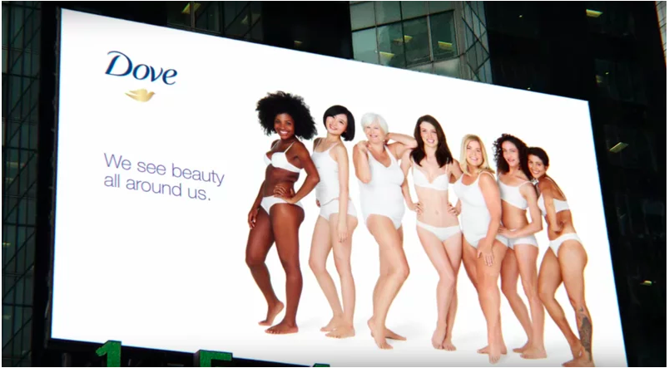
Dove, which started out as a company known solely for selling plain white bars of soap, has since morphed into a leader in body care products for men and women. Around the turn of the century, the company realized it needed to make some drastic changes in order to stay relevant in a world being bombarded with products and marketing from all angles.
In the early 2000s, Dove executives began looking for a way to revive a brand that was being overshadowed by other companies. Their PR agency, Edelman, conducted a study of more than 3,000 women in 10 countries in order to learn about women’s priorities and interests. When it reported that only 2 percent of the women interviewed considered themselves beautiful, the executives at Dove saw an opportunity. As they moved beyond the bar of soap and introduced other products such as shampoo and body wash, could they also start a conversation about beauty? Would a campaign that tapped into what women were thinking and feeling help Dove become more relevant — and more profitable? (Bahadur, 2017)
Thus began Dove’s famous “Real Beauty” campaign, which has lasted more than a decade and is still relevant to this day. The campaign kicked off with a show organized by Dove and PR agency Ogilvy & Mather called “Beyond Compare: Women Photographers On Real Beauty” which featured work from 67 female photographers. Later came one of the most famous pieces of propaganda associated with Dove, and a highlight of their “Real Beauty” campaign. A billboard campaign featured diverse groups of untouched, unedited women in their underwear. The women are of all different shapes, sizes, ages and skin tones yet they all have one thing in common, they appear to be happy and confident in their own skin. The purpose of this campaign was to teach women to love their bodies and to be confident in their natural skin. The strong message of women empowerment helped Dove rebrand itself by shaping attitudes and associating positive messages with the company.
Dove’s “Real Beauty” campaign has all of the components typically seen in modern-day propaganda. It presents a strategically-crafted message with eye-catching images that provoke strong emotions. It is rare to see a billboard with pictures of real-looking people, not size 0 models, advertising a beauty product. This shock factor is what initially draws people into the piece of propaganda, and possibly makes them interested in learning more about the company and campaign. “It's won a plethora of ad awards and sold a heap of product -- sales have jumped to $4 billion today from $2.5 billion in its inaugural year. But has it changed perceptions?
Dove claims it has.” (Neff, 2014) It appears that this tactic was highly successful in increasing revenue for Dove and bringing loads of attention to the company, since the campaign has won numerous awards over the past decade and is renowned for its positive message.

Comparing and Contrasting the Campaigns
Dove’s modern “Real Beauty” campaign and the 1960s ironized yeast “Men Wouldn’t Look At Me When I Was Skinny” advertisement are both powerful examples of the ability of propaganda to influence attitudes. In these examples, the propaganda focuses on shaping the way women view their bodies. Women have been exploited by advertisements for years, as the tactic of playing on their body image insecurities has proven to sell products. There have been entire industries built on the idea that women should be beautiful and thin, hence the plethora of makeup and diet products available on the market. As shown in the 1960s advertisement, this practice of playing on women’s emotions and insecurities to sell products has been going on for decades. Nowadays, companies have had to come up with new approaches to the body image trend in order to attract more consumers. It is no longer socially acceptable to blatantly shame skinny people in advertisements, especially since “skinny” is now the ideal for the majority of American women. Dove took this a step further and decided to try to empower women with its advertising, which is still a form of influencing how women view their bodies. While they have very different messages, both of these propaganda examples share the goal of shaping the way women view their bodies and selling the brand’s products.
A major difference between the two pieces of propaganda is the message they send to their target audience, women. The 1960s advertisement aims to make skinny women feel insecure about their bodies and promote curvy, voluptuous figures as the ideal. The 2000s Dove advertisement’s goal is to empower women and make them feel confident in their bodies, no matter what they look like. This shift in attitude is part of a larger societal movement, which can be seen with an overall cultural change in perception of body image. While many brands do still showcase extremely thin models and sell an abundance of women’s beauty products, it would be uncanny to see an advertisement that said something along the lines of “Men wouldn’t look at me when I was skinny.” This difference in propaganda language exhibits how much advertising and marketing has evolved over the past few decades.
Another shift in propaganda over the last few decades is shown in the overall quality of each of these examples. Clearly, the 1960s advertisement lacks the vibrant colors and image quality that technological advances have brought to modern propaganda. The Dove ad, although it does not use much color, still features a clear, vivid image. Additionally, the 1960s advertisement has a lot more words on it then the 2000s advertisement, and most advertisements in this age for that matter. In the 1900s, it was much more common for advertisements to include long descriptions of products attempting to persuade consumers to buy them. Now, in most advertisements, the less words the better. Consumers are constantly bombarded with information, so they do not take the time to read advertisements, especially if they include paragraphs of writing. The Dove “Real Beauty” campaign features an image with very few words and the Dove logo. In today’s world, using a strong, eye-catching image with minimal words is more effective propaganda than long, wordy print advertisements.
Overall, these two examples of propaganda exemplify the strategies advertisers use to sell their products and influence attitudes towards their brands. Their powerful messages were able to influence women’s perceptions of body image, whether in the 1960s or 2000s. Propaganda has clearly evolved a great deal over the years, but so has society’s beauty standards. These two pieces of propaganda have more in common than may appear at first glance; they were both used to start cultural movements and promote what the “ideal” woman’s body image should be.
References
Backer, B. The Care and Feeding of Ideas (New York: Crown, 1993)
Bahadur, N. (2017, December 06). How Dove Tried To Change The Conversation About Female Beauty. Retrieved March 28, 2019, from https://www.huffpost.com/entry/dove-real- beauty-campaign-turns-10_n_4575940
Berelson, B. "Public Opinion and Propaganda. Leonard W. Doob," The Library Quarterly 19, no. 3 (Jul., 1949): 230-231.
Cortese, A. J. (2016). Provocateur: Images of Women and Minorities in Advertising(3rd ed.). Lanham, MD: Rowman & Littlefield. Retrieved March 28, 2019, from https://studiidegen.files.wordpress.com/2009/03/c8_cortese_constructed-bodies- deconstructing-ads.pdf.
Krupnick, E. (2011, November 29). Vintage Weight Gain Ads Discourage Skinny Bodies. Retrieved March 29, 2019, from https://www.huffpost.com/entry/vintage-weight-gain- ads_n_1119044
Neff., J. (2014, January 22). Ten Years In, Dove's 'Real Beauty' Seems to Be Aging Well. Retrieved March 28, 2019, from https://adage.com/article/news/ten-years-dove-s-real- beauty-aging/291216/
Poepsel, M. (n.d.). Media, Society, Culture and You. Retrieved March 28, 2019, from https://press.rebus.community/mscy/chapter/chapter-10-advertising-and-propaganda/
Qualter, T. H. Propaganda and Psychological Warfare. New York: Random House, 1965, p. 27.
Shover, M. J. (n.d.). Roles and Images of Women in World War I Propaganda. Retrieved March 28, 2019, from https://journals.sagepub.com/doi/pdf/10.1177/003232927500500404
The New Penguin English Dictionary. London: Penguin, 2000.
The Person: Subject and Object of Propaganda. Annals of the American Academy of Political and Social Science 179 [1927]: 189).
The Story of Propaganda. (n.d.). Retrieved March 28, 2019, from https://www.historians.org/about-aha-and-membership/aha-history-and-archives/gi- roundtable-series/pamphlets/em-2-what-is-propaganda-(1944)/the-story-of-propaganda

