Top 10 Things You Should Know about Propaganda
In just one short semester, I learned A LOT about propaganda. I went from not really knowing what it meant for something to be considered “propaganda” to knowing how to define it, recognize it, analyze it and create it. Here are the top 10 insights that everyone should know about propaganda that I learned from studying it for a semester:

- Propaganda has a different definition depending on who you ask
When I enrolled in COM416, Propaganda, last semester, I would not have been able to come up with a definition for the word itself. Now, I have learned a plethora of definitions for propaganda, and have seen how it has evolved over time. In class, we learned a variety of definitions for propaganda spanning from the 1920s to today. Even now, propaganda may have a different meaning depending on who you ask, and what their understanding of it is. This is key to remember when learning about propaganda.
1920s: “Propaganda is the executive arm of the invisible government” (p. 20). “Propaganda will never die out. Intelligent men must realize that propaganda is the modern instrument by which they can fight for productive ends and help to bring order out of chaos” (p. 159). Edward L. Bernays. Propaganda. New York: Liveright, 1928.
1930s: “Propaganda is promotion which is veiled in one way or another as to (1) its origin or sources, (2) the interests involved, (3) the methods employed, (4) the content spread, and (5) the results accruing to the victims—any one, any two, any three, any four, or all five.” Frederick E. Lumley. The Propaganda Menace. New York: Century, 1933, p. 44.
1940s: “Propaganda in itself has no fundamental method. It has only purpose—the conquest of the masses.” Joseph Goebbels (then Nazi German minister for propaganda). Quoted in Political Propaganda, by Frederic C. Bartlett. Cambridge: Cambridge University Press, p. 66.
1950s: “Propaganda in the broadest sense is the technique of influencing human action by the manipulation of representations. These representations may take spoken, written, pictorial or musical form.” Harold D. Lasswell. “Propaganda.” In International Encyclopedia of the Social Sciences. Vols. 11–12. New York: Macmillan, 1950, pp. 521–522.
1960s: “Propaganda is the relatively deliberate manipulation, by means of symbols (words, gestures, flags, images, monuments, music, etc.), of other people’s thoughts or actions with respect to beliefs, values, and behaviors which these people (“reactors”) regard as controversial.” Bruce L. Smith. “Propaganda.” In International Encyclopedia of the Social Sciences. Vols. 11–12. New York: Macmillan, 1968, p. 579.
1980s: “[Propaganda is] the systematic propagation of information or ideas by an interested party, especially in a tendentious way in order to encourage or instil a particular attitude or response.” Terrence H. Qualter. Opinion Control in the Democracies. London: Macmillan, 1985, 124.
1990s and after: “The usually organised spreading of ideas, information, or rumors designed to promote or damage an institution, movement, etc.” The New Penguin English Dictionary. London: Penguin, 2000.
When I first tried to create my own definition of politics in the beginning of the semester, my mind kept turning to politics, because that is what I thought propaganda was used for. Now, I have learned about all of the many uses for propaganda, and how its definition may change according to the circumstance. Clearly, it is not solely used for political purposes. At the end of the semester, I have a much better idea of what “propaganda” means, and how its meaning has changed over time.
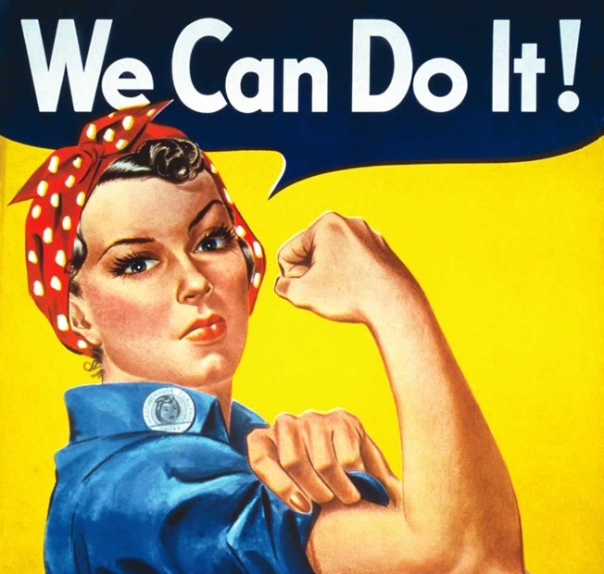

- Obvious lies make great propaganda
In learning about propaganda, it only makes sense to examine how it is used today by our very own president, Donald Trump. Even before his presidency, Trump was famous for his charisma, strong personality and ability to lead the masses with his ideas - first in business and then in politics. Now, he has coined the term “fake news” to describe information he wants the public to believe is false and to further his own agendas. This video explains how Trump tells obvious lies, “more than he can even keep up with,” and how it functions as a form of propaganda. When people hear lies repeatedly and from multiple sources, they are much more likely to believe it.
Trump is not the only leader who has used this form of propaganda, Vladimir Putin and Dick Cheney have been caught, as well. The tactic is called “firehosing” and is used as a method of persuasion and a demonstration of power. These leaders recognize that people probably know what they are saying is a lie, but say it anyway because they can. This is an issue because they are taking the power away from the truth, by providing their own versions of the truth that further their own agendas.
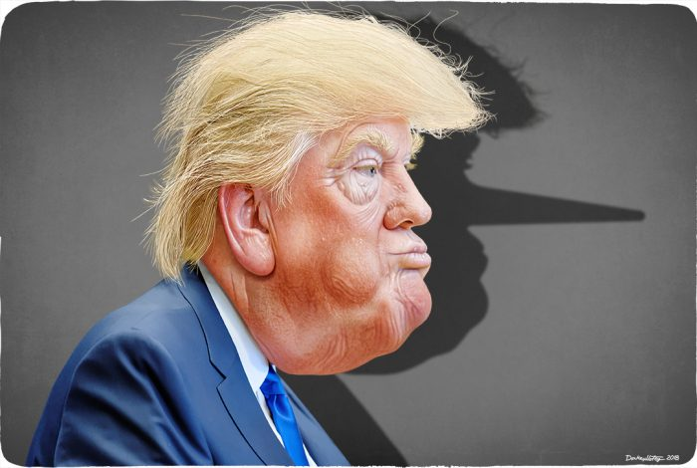

- What do you MEME memes can be propaganda?!
As a millennial, I enjoy looking at memes on social media and sharing them with my friends when I believe they are funny or relatable. Memes are a big part of today’s culture and account for a lot of time spent on social media. This semester, I critically analyzed memes to understand how they can be used as propaganda. This opened a new door for me, as I was only used to seeing memes used for humor and entertainment purposes. After learning more about them, I realized that they work great as a form of propaganda because they are emotion-evoking, attention-grabbing, easy to understand and spread quickly on the Internet.
One example in particular that I analyzed is shown below. It reads: “If illegal aliens use plastic straws in California will they finally deported.” This meme serves as propaganda by combining two current issues in society: the presence of illegal aliens in America and the environmental issue of plastic, that California is fighting by banning plastic straws. While the meme pokes fun at these two issues, it also helps spread the message in an attention-grabbing, emotion-evoking way. Many people feel strongly about the issues of illegal aliens and climate change, so this meme is an effective form of propaganda.

- Fake news, disinformation, conspiracy theories, OH MY!
To learn about fake news, disinformation and conspiracy theories, I took a dive into the world of fake news, and even played a game that showed us via a simulation how quickly and easily fake news spreads on social media sites like Twitter. I was able to spread “bad news” myself to learn how fake news and rumors spread on the Internet. I also watched videos of previous COM416 students explaining a conspiracy theory of their interest. This helped me make the connection between conspiracy theories and propaganda, because they have similar attributes that help them spread rapidly.
Lexicon of Lies explains topics like the difference between “misinformation” and “disinformation” and how propaganda fits in. “Without careful use of the terminology associated with these problematic forms of information — misinformation, disinformation, propaganda, gaslighting, and the like — important distinctions between these different phenomena can be lost” (Jack, 14). Reading this helped me distinguish between concepts like conspiracy theories, disinformation and fake news, and showed me how they are all different, but interconnected. Each of these concepts relates to propaganda in that they can be used to spread information that is not completely true, usually with the purpose of benefiting the propagandist.
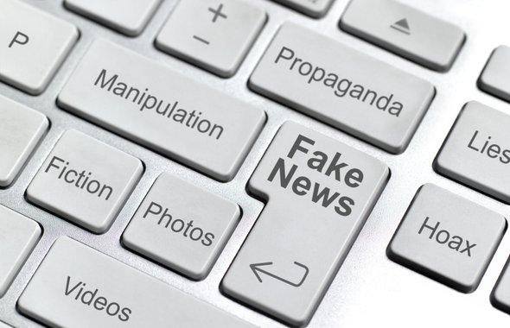

- Fake it until you make it: Instagram influencers create “fake” sponsored content
There is now another reason to not blindly trust everything you see on the Internet, especially on social media. People who are trying to become Instagram influencers are creating their own “fake” sponsored content to make themselves seem more important, or more influential. These people are typically trying to get brands to notice them and want to work with them, but have not yet gotten the attention or clout they need to do so. This video explains this phenomenon, and how it is working for some wannabe influencers. However, this is causing some confusion on the Internet, because these fake ads are making it hard to distinguish between posts that are actually sponsored and those that are not.
Reading this article made me think of how often I see people promoting products on Instagram and just assume they are sponsored or being compensated for their posts. I never thought about the possibility of "influencers" not actually being paid influencers. Knowing how much some influencers get paid, "faking it" seems like a creative idea to get to the top. However, as brands become more aware of this, they have to start doing more research before giving someone a sponsorship. The value of influencers is starting to decrease dramatically since more people are pretending to be sponsored influencers. This “fake spon con” is being described as a “race to the bottom” because people are willing to promote brands and products for free. Now, the brands are less likely to want to pay actual influencers big money because they do not have to. The other issue is that people cannot fully trust what they see online because it could be a fake sponsored post made to appear like it was created in a deal with the brand. Likewise, brands cannot always trust the Instagrammers they see promoting products, because they might just be doing it in hopes of actually getting sponsored someday.
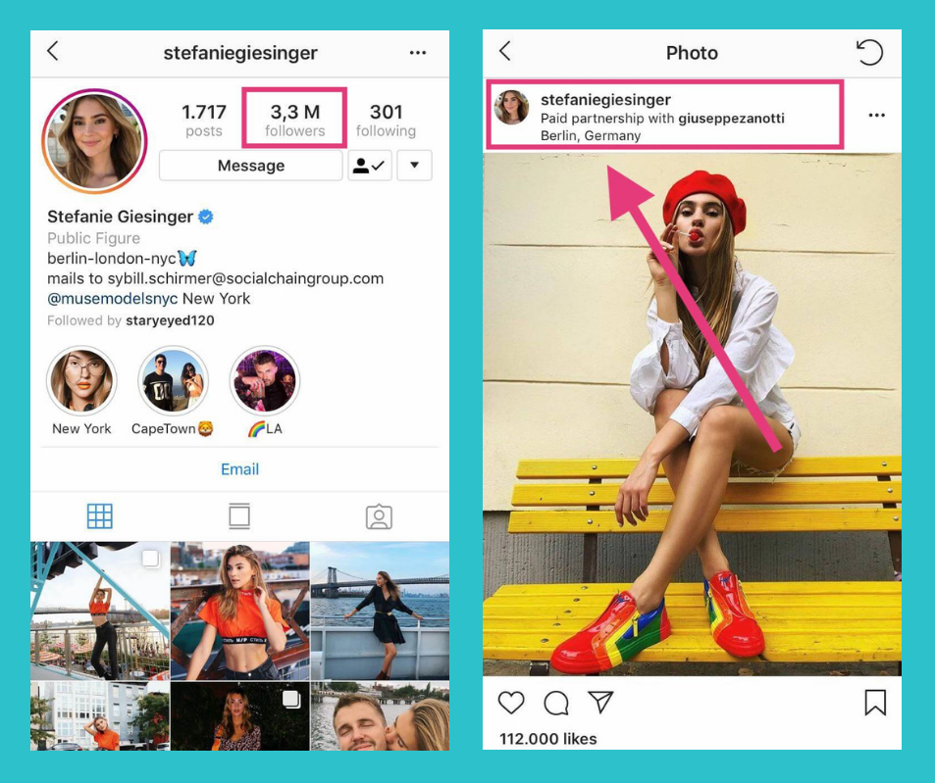

- Newsflash: Network propaganda exists
Learning about networked propaganda helped me understand how different news outlets function with explicit biases. This was not something I always paid attention to when gathering news, but now it is one of my top priorities. When I want to find out the “truth” about a news event, I now look at multiple sources to try to gather the facts hidden within each media outlet’s biases. Networked propaganda is arguably more prevalent than ever before with the reign of America’s most controversial president. From the start of Trump’s campaign, it was clear which media outlets supported him based on their political party lean, and which scrutinized his every move. Sources like Fox and the Wall Street Journal are more conservative, while MSNBC and Vox are more liberal.
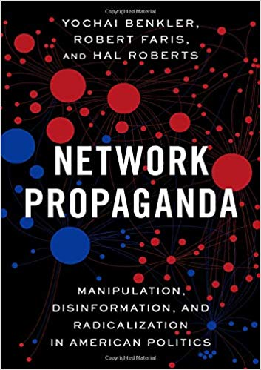

- You better watch out for trolls and bots!
With current events like the Russians meddling in the most recent presidential election, it seems that Internet trolls and bots are receiving more attention than ever before. Before learning more about trolls and bots and their relation to propaganda, I believed they were just a myth. Now, I have learned about the different ways they can control what is seen and published on the Internet. An example that stuck with me was the article that talked about how fake Tinder profiles were created and used to sway voters in the UK. “A group of young activists built a Tinder chatbot to co-opt profiles and persuade swing voters to support Labour. The bot accounts sent 30,000-40,000 messages to targeted 18-25 year olds in battleground constituencies like Dudley North, which Labour ended up winning by only 22 votes” (Gorwa and Guilbeault, 2017). As seen in the United States election, trolls and bots do have the power to influence voters. It is not just Russia that is meddling with elections. People all over the world have found creative ways to use the Internet to spread their propaganda and influence politics; Tinder is just one example of this.
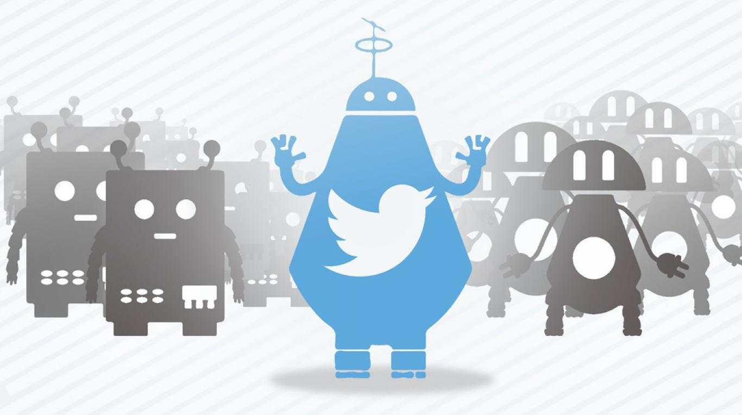

- Propaganda can be used as a terrorist weapon…
Learning about how terrorists use propaganda to recruit more terrorists was slightly frightening, especially because of how common it is. As we know, propaganda has the power to be extremely persuasive, which is why terrorists use it to recruit their members. They have been effective in doing so with videos like this one, which uses English language. It is concerning to me that Isis has been able to recruit new members, even from Western countries, through the use of propaganda. This shows how powerful and persuasive it can be, especially when used for evil.
On the other hand, I learned how countries like New Zealand are working to stop the spread of terrorist propaganda. For example, after the recent New Zealand mosque shooting, the country made it illegal to share the video of the shooting on social media. This article explains the country’s reasoning behind wanting to stop the spread of terrorism propaganda online. I believe New Zealand is taking a step in the right direction by banning this type of action on social media. It could help stop copycats who see this sort of violence online and decide to mimic it. Additionally, I do not think people should be able to view the murders of other people live on the Internet. This type of violence is extremely harmful to society and should not be spread on social media.

- … but also for entertainment purposes
Learning about how propaganda is used for entertainment purposes was interesting to me because once I analyzed some examples, I was able to think of times I have seen entertainment propaganda. My favorite example is the movie “The Interview.” I remember watching the movie a couple years ago and thinking a lot about how they portrayed North Korea. Now that I have learned about propaganda, I realize that this movie is a perfect example of propaganda being used for entertainment purposes. I liked seeing the examples my classmates thought of and reading their ideas on this Padlet wall. Recognizing different examples of entertainment propaganda showed me another side of propaganda I was not previously aware of. It can be used to take a serious idea or concept, like North Korean politics for example, and make it into a funny satire.
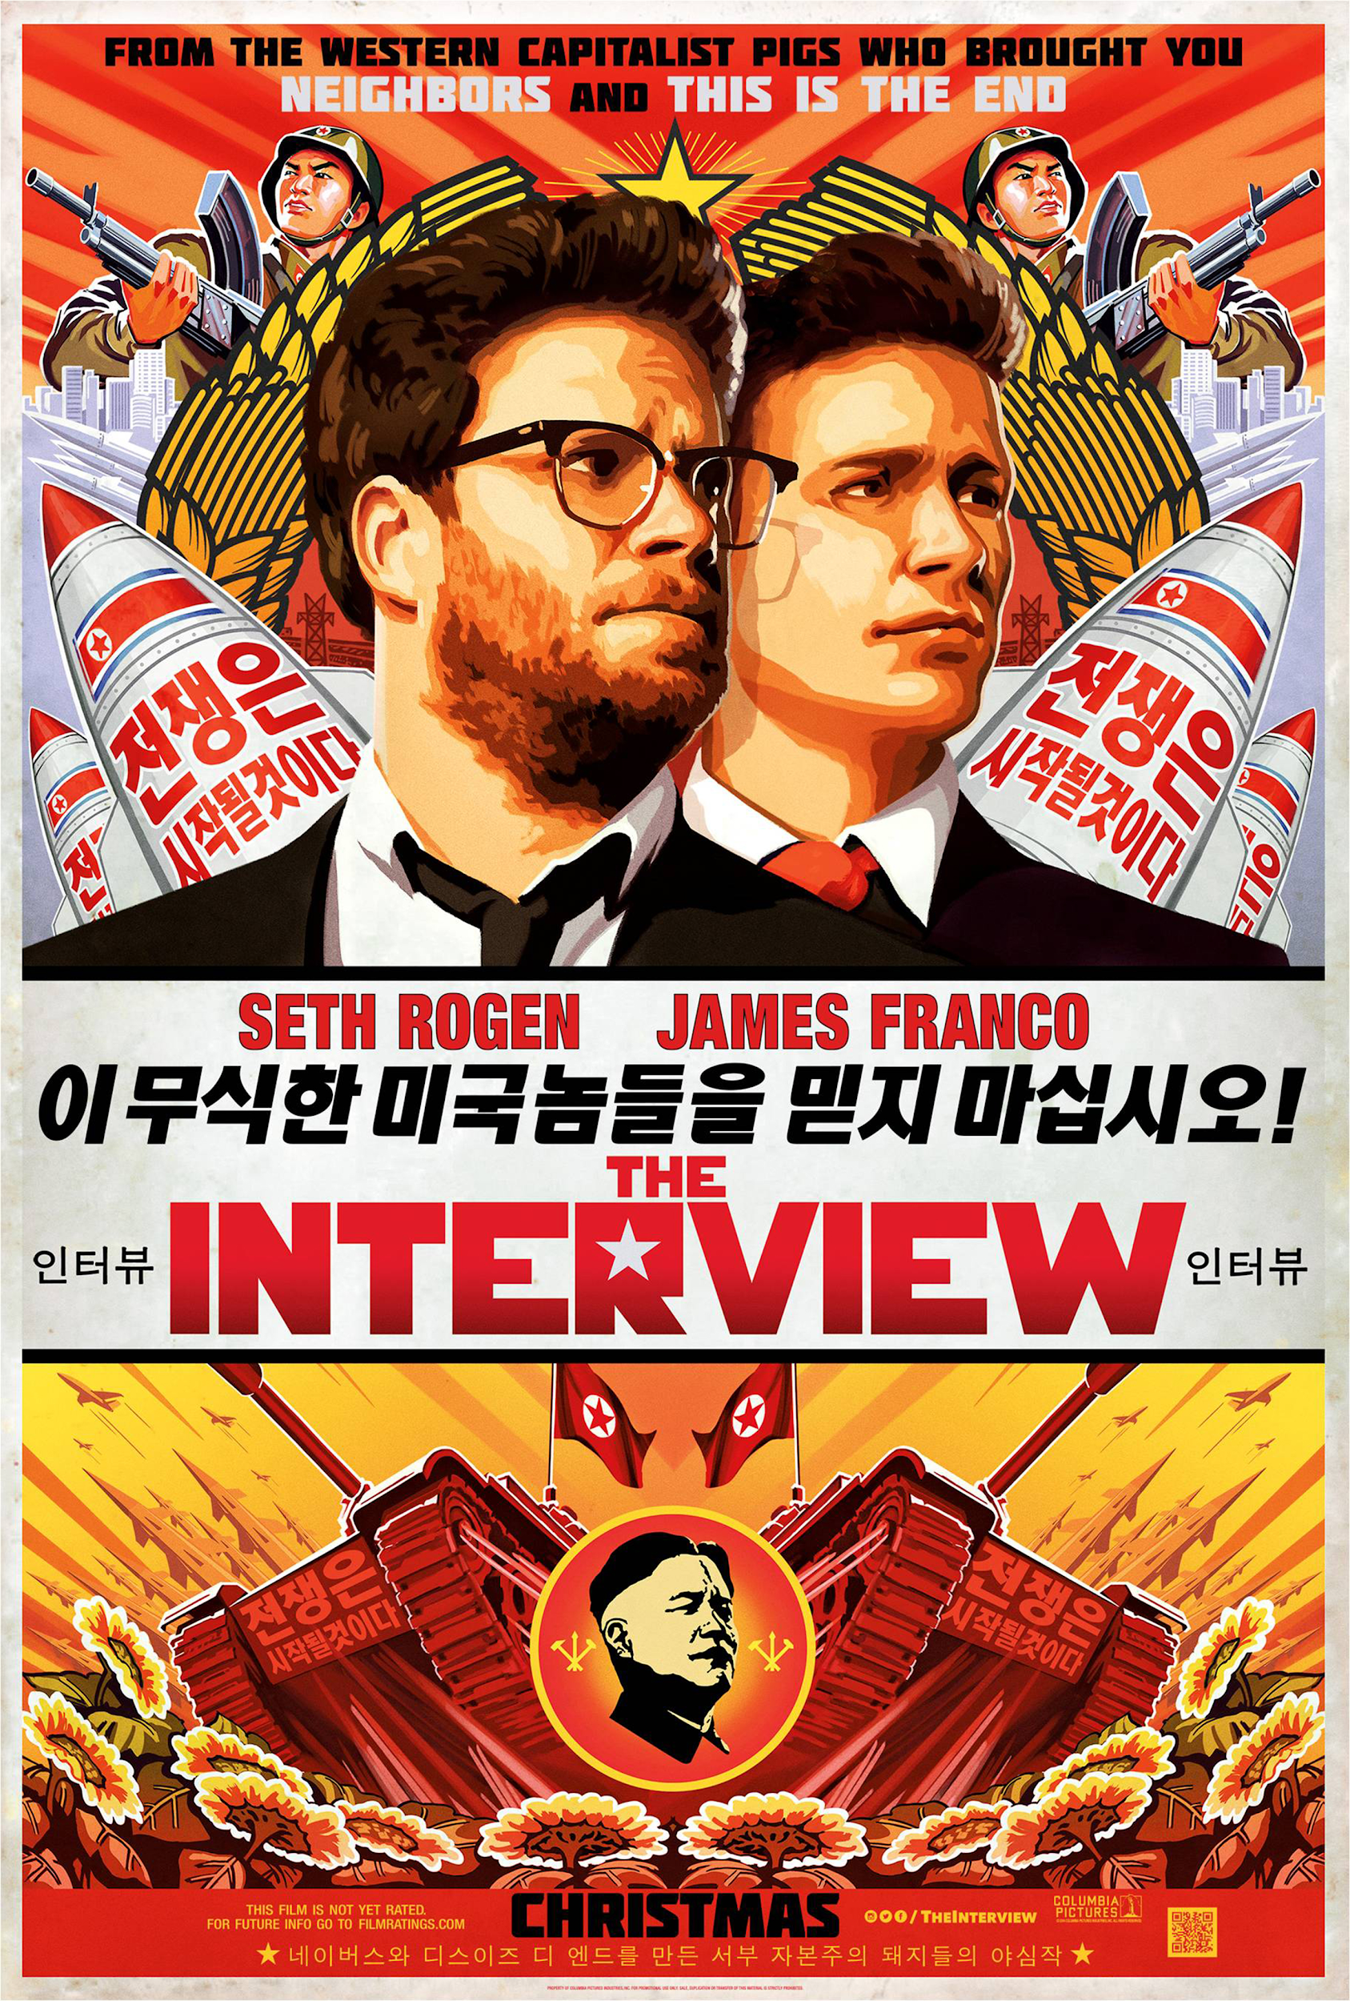

- Propaganda is not all evil; it can be - and is - used for good too!
Propaganda is not always used for bad, or for political purposes. It can, and is, used for good, too. Many public service campaigns are considered propaganda because they work to bring important information to the public’s attention in an attention-grabbing, often dramatic way. Many public service announcements are about issues like car safety, the dangers of alcohol and drugs, and preventing the spread of diseases through safe sex practices and vaccinations. In this way, propaganda serves as a means of communicating important messages and influencing the opinions of mass audiences. While some view persuasive propaganda as manipulative, when used for the good, it can truly help people.
An example of beneficial propaganda I analyzed in class was the Kony 2012 video, which is a great example of how propaganda can be used for the good. When this video was released, it quickly went viral, helping the message about Kony spread. Very shortly, almost everyone knew about Kony and had seen the video. In this way, a propaganda video helped spread awareness and evoked strong emotions about an important issue that needed to be brought to the public’s attention.
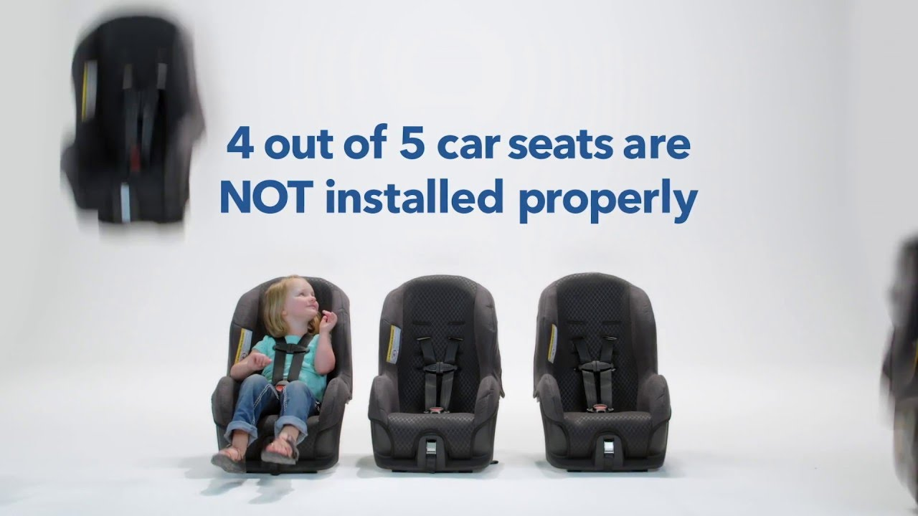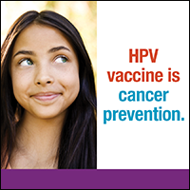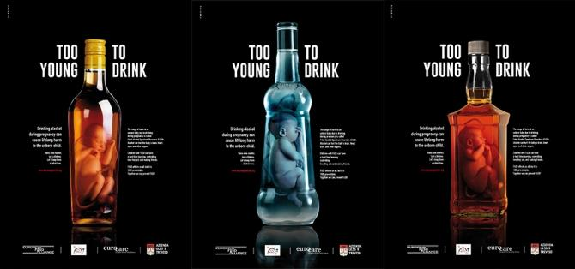
Works Cited
Bruce L. Smith. “Propaganda.” In International Encyclopedia of the Social Sciences. Vols. 11–12. New York: Macmillan, 1968, p. 579.
Edward L. Bernays. Propaganda. New York: Liveright, 1928.
Gorwa, R., & Guilbeault, D. (2017, July 07). Tinder nightmares: The promise and peril of political bots. Retrieved May 3, 2019, from https://www.wired.co.uk/article/tinder-political-bots-jeremy-corbyn-labour
Frederick E. Lumley. The Propaganda Menace. New York: Century, 1933, p. 44.
Graham-McLay, C. (2019, March 22). Spreading the Mosque Shooting Video Is a Crime in New Zealand. Retrieved May 3, 2019, from https://via.hypothes.is/https://www.nytimes.com/2019/03/21/world/asia/new-zealand-attacks-social-media.html#annotations:query:
Harold D. Lasswell. “Propaganda.” In International Encyclopedia of the Social Sciences. Vols. 11–12. New York: Macmillan, 1950, pp. 521–522.
Jack, C. Lexicon of Lies: Terms for Problematic Information. Data & Society.
Joseph Goebbels (then Nazi German minister for propaganda). Quoted in Political Propaganda, by Frederic C. Bartlett. Cambridge: Cambridge University Press, p. 66.
Lorenz, T. (2018, December 18). Rising Instagram Stars Are Posting Fake Sponsored Content. Retrieved May 3, 2019, from https://www.theatlantic.com/technology/archive/2018/12/influencers-are-faking-brand-deals/578
Terrence H. Qualter. Opinion Control in the Democracies. London: Macmillan, 1985, 124.
The New Penguin English Dictionary. London: Penguin, 2000.

