Harrington School students visit Alex and Ani headquarters
By Taylor Stickles
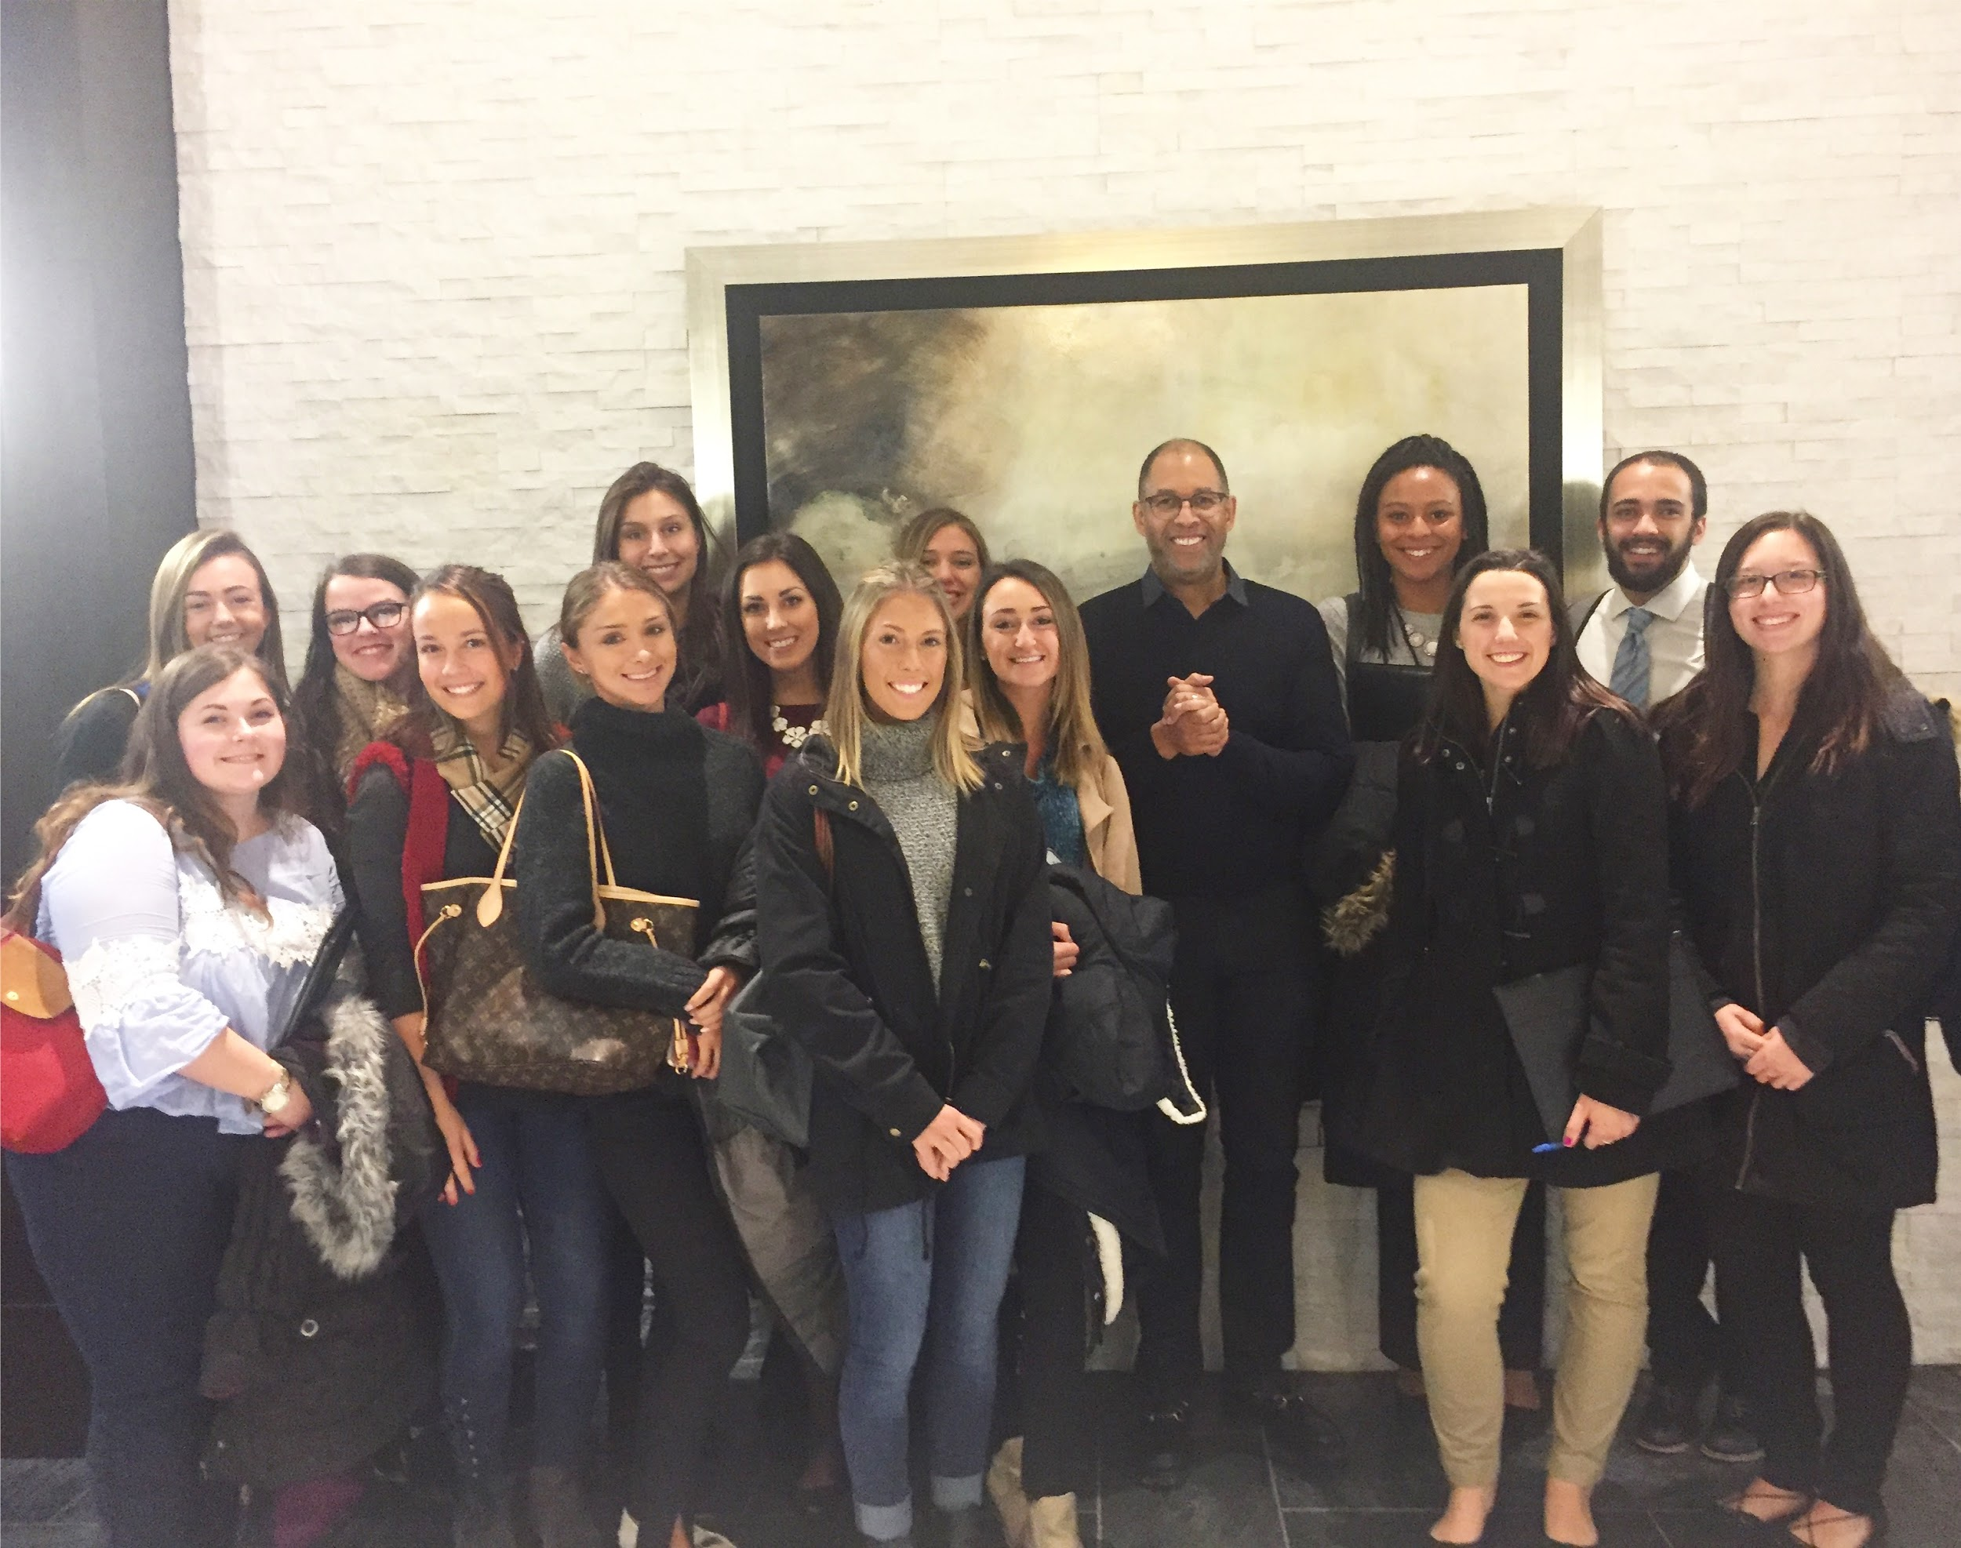

The Harrington School of Communication and Media at URI provides students with real-world experiences to enrich their education and help them learn valuable networking skills.

“I’ve never applied for a job in my life, it’s always been through relationships,” stated Mark Coleman, vice president of university relations at Alex and Ani. Coleman and his colleagues hosted University of Rhode Island Harrington School students at the Alex and Ani headquarters in Cranston, RI so that they could learn about the digital marketing tools and strategies used to promote their products and culture.

Alex and Ani is a Rhode Island-based jewelry company founded by Carolyn Rafaelian. The company does so much more than sell widely popular bangle bracelets. They are the “original meaning makers” who strive to make a positive impact on the world by giving back to charities and spreading positive energy.

The company does not follow conventional trends. Rather, they incorporate lifestyle trends that fit their culture, such as spirituality and astrological signs. They use analytics to look at reach, loyalty, engagement and conversions to “know their audience.”

Sarah Viens, a former intern for Alex and Ani, now works full-time for the company as a junior content marketing associate. She talked to students about the behind-the-scenes work that goes into producing content for the company’s social media.

“Each platform is a different way of storytelling and has a different audience...sometimes it can even take up to four people to perfect one Instagram photo,” Viens revealed.

She also stressed to students the importance of strong writing skills and building a brand name for yourself. Alex and Ani has a team of creative individuals, and the company looks for people who empower others through writing.

“We do a good job being authentic because our story is real,” Coleman said. “We are a meaning company that happens to sell jewelry.”

As a company that promotes positive energy and contribution to charity, Alex and Ani’s goal is to sell meaning and empower people. The jewelry is meant to connect you to the things that are important to you. The company spreads meaning and inspiration daily through its corporate blog.

Coleman also gave students valuable advice on landing their dream internships and jobs in the future.

“Every time you have a new experience it adds to your library - always collect,” Coleman said. “Grab as much ammunition for yourself as possible.”

Harrington School field trips such as this one provide students with the “ammunition” and valuable experiences that they need to succeed.

